Faculty of Computing
Class: BSCS-2023-CD Course: CS-346 Compiler Construction
Lab 04: Starting Flex for Lexical Analysis
Date: 19, Feb 2026

Lab Instructor: Ms. Urooj Akmal Instructor: Ms. Yusra

NAME | ABRAR BUTT
QALAM ID | 460297
SECTION | C

Introduction
The lexical analyzer is the part of the compiler that reads the source text. It may also perform certain secondary tasks at the user interface. One such task is stripping out comments and white space in the form of blanks, tabs, and new line characters from the source program. Another is correlating error messages from the compiler with the source program, i.e., keeping correspondence between errors and source line numbers.

Objectives
1. Successful understanding and implementation of basic Lexical Analysis using Flex on Windows.

Tools/Software Requirements
- inFlexBison (Flex for Windows)
- MinGW or TDM-GCC (C compiler for Windows)
- Command Prompt / PowerShell
- Text Editor (VS Code / Notepad++ / Sublime)

Installation Steps on Windows
Step 1: Install WinFlexBison
Download and install WinFlexBison from:
https://github.com/lexxmark/winflexbison
After installation, add its bin folder to the System Environment PATH.
Verify installation:
win_flex --version win_bison --version

Step 2: Install MinGW (GCC Compiler)
Download MinGW from:
https://www.mingw-w64.org/ Add bin directory to PATH.
Verify:
gcc --version
Running Flex Program on Windows
Suppose your file is: test25.l

Step 1: Generate C file from Flex
win_flex test25.l This will generate: lex.yy.c
Step 2: Compile Generated File
gcc lex.yy.c -o output.exe

Step 3: Run the Program
output.exe

Lab Tasks
Description:
Lexical analysis is the process of converting a sequence of characters into a sequence of tokens.
A program or function that performs lexical analysis is called:
- Lexical Analyzer
- Lexer
- Scanner
Flex generates a C source file (lex.yy.c) which is compiled using GCC on Windows.
Flex in a Nutshell (Tutorial)
Go through the Flex handout provided on LMS and understand:
- Structure of .l file
- Definitions section
- Rules section
- User code section
- Pattern matching
- Token generation
Task 1:
Overcome the deficiency of not recognizing the operators for the code given in: “Help to Start Lab on flex” (available on LMS).
Make sure your updated lexer:
- Recognizes arithmetic operators (+, -, *, /)
- Recognizes relational operators (==, !=, >, <, >=, <=)
- Recognizes logical operators (&&, ||, !)
Task 2:
Propose any improvement of your own choice and demonstrate it in a Word/PDF file.
Examples of improvements:
- Line number tracking
- Better error messages
- Identifier validation
- Keyword recognition
- Comment handling

Outputs:

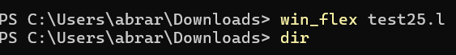
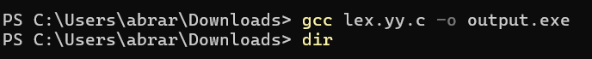
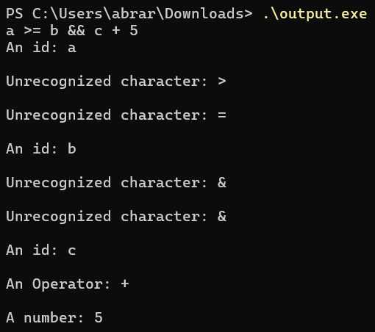
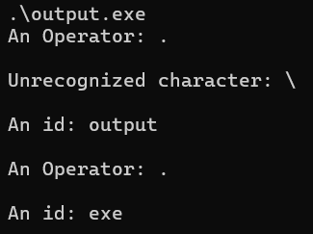

Task 1 & 2:
Outputs:

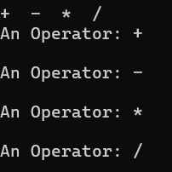
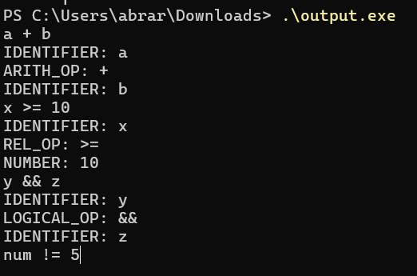

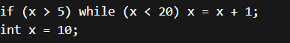
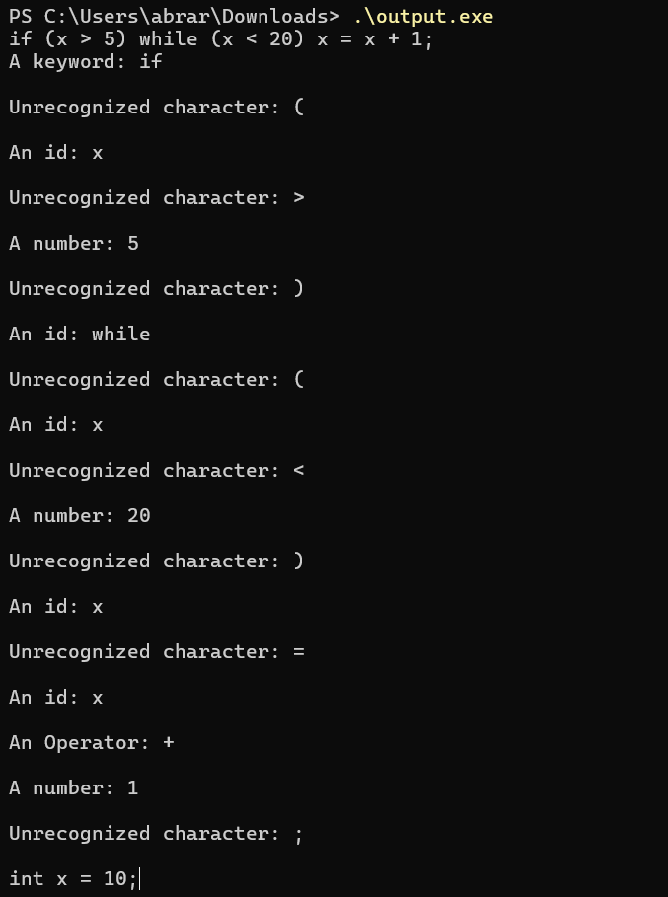

Deliverables
You are required to upload your task (Sources & Word/PDF document) using the link created on LMS followed by a viva or quiz. Your word file should contain a screenshot of your output.
Note: The most crucial task is successfully:
- Running Flex on Windows
- Generating lex.yy.c
- Compiling using GCC
- Executing the program without errors test25.l is available on LMS to test Flex.

For report link and files:

Note: https://github.com/Abrarbut/compiler-construction.git

